Binteo

- 3.3) Invalid Email Validation
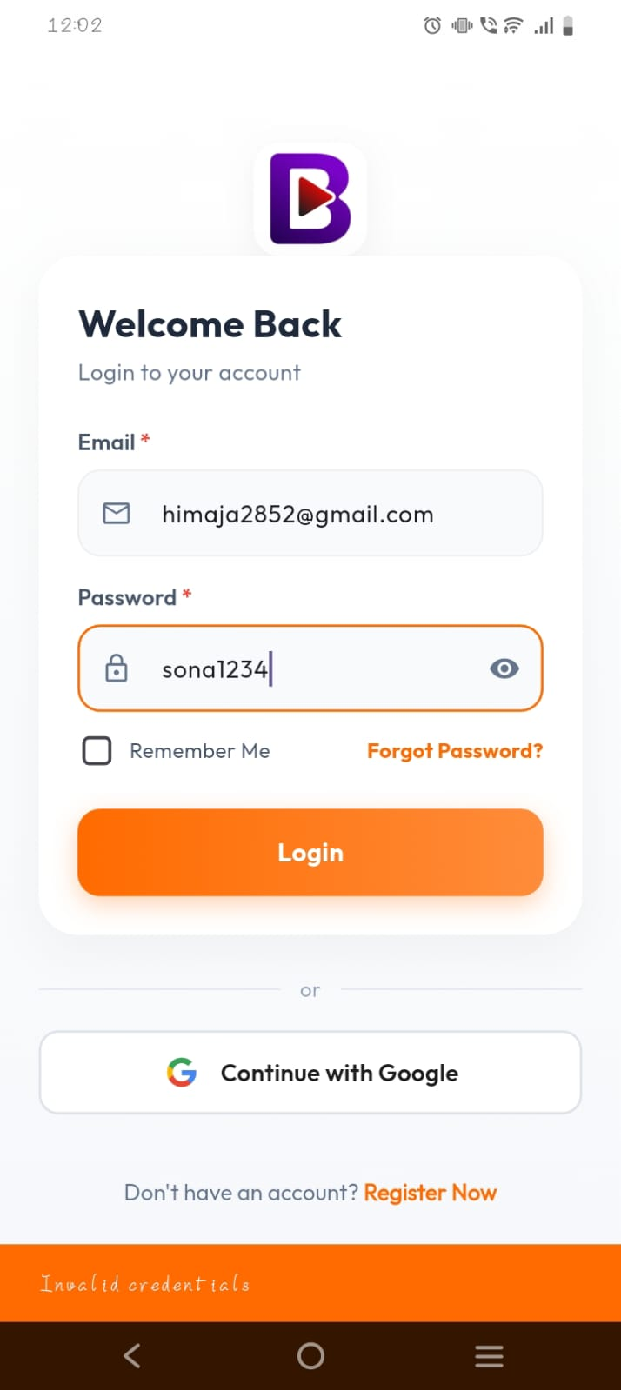

Status: PASS
Tested on: vivo y28 5g
- 5.2) Featured profile

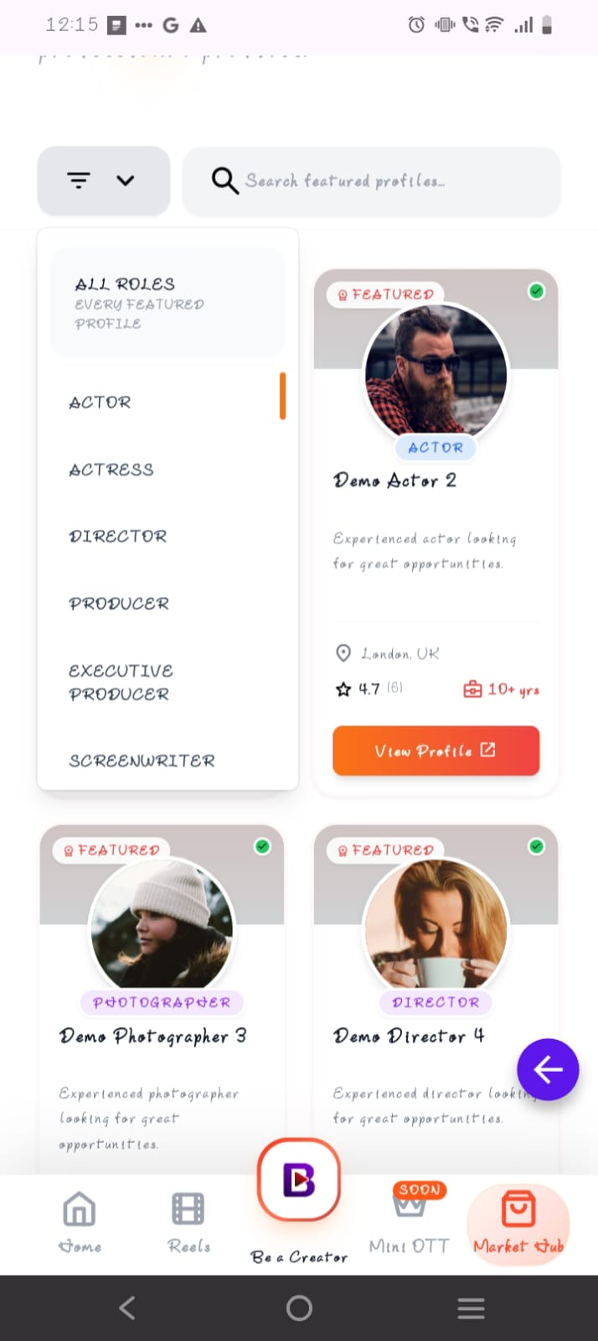

Status: pass
Tested on : vivo y28 5g
- 5.1) Profile Testing

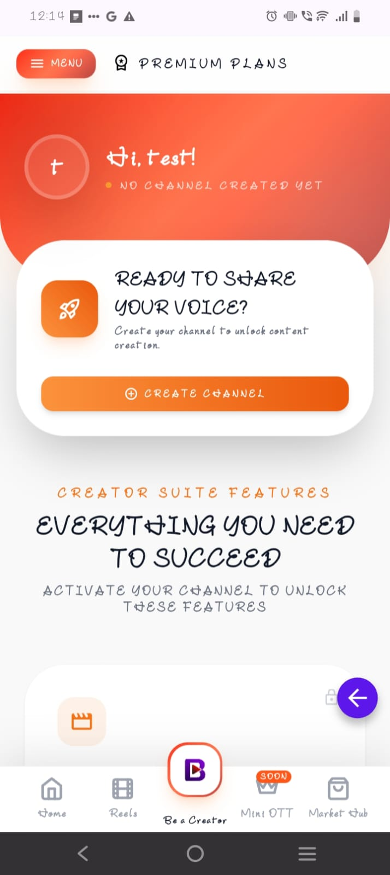

Status:pass
Tested on: vivo y28 5g
- 5.3)creator showcase

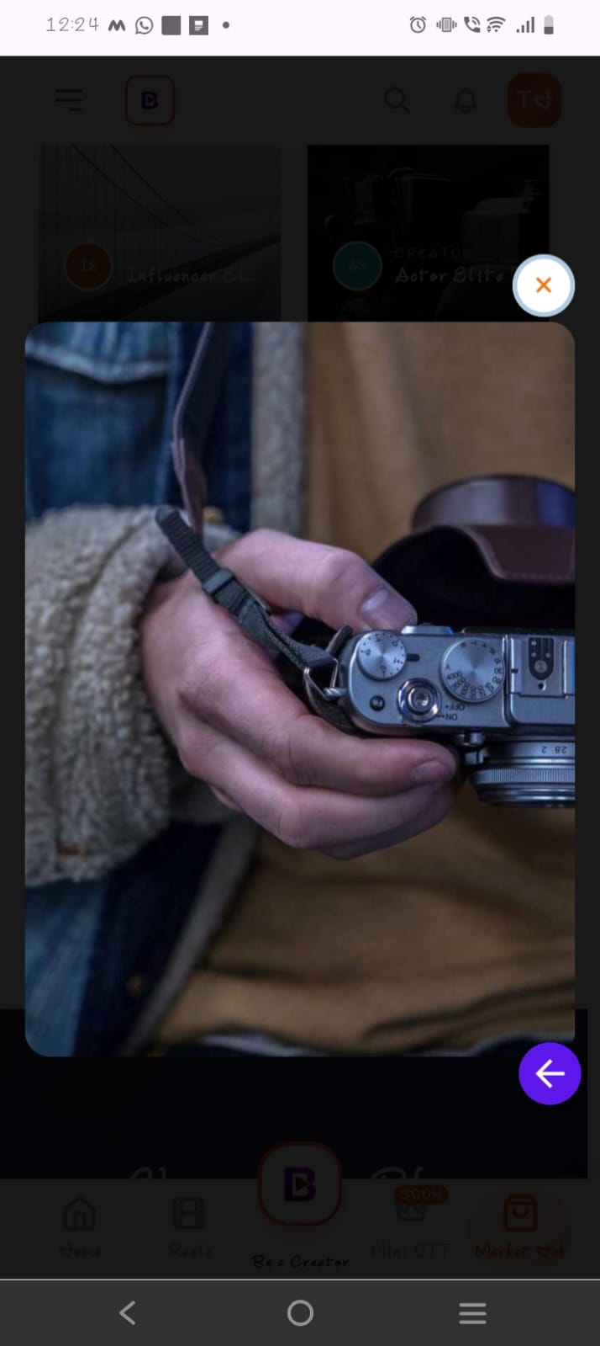
Status: pass
Tested on: vivo y28 5g

5) Navigation Testing

https://drive.google.com/file/d/1BI0rcqzsjLsSw9usHqQZr_Kpxgc5-7LA/view?usp=drive_link

status: pass
tested on: vivo y28 5g

6) Entertainment section scrolling – vivo y28 5g

https://drive.google.com/file/d/1Tb4cK2UPttkw7CNAH6pvE2xsoT-kH5Iv/view?usp=sharing

status: pass
tested on: vivo y28 5g

7) support desk testing

Buttons are visible

Status : pass

Tested on : IQOO Neo 9 Pro

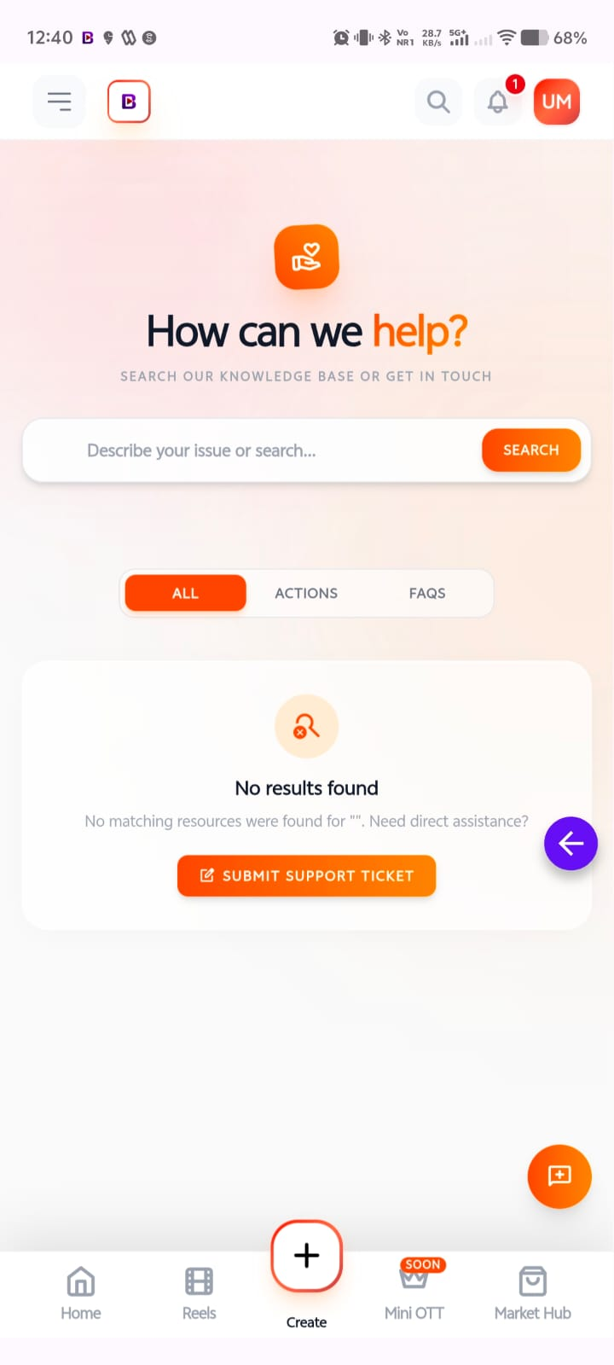

8) reel audio button

https://drive.google.com/file/d/1Y7UkucJuLTMQDn8pmQlZQd-8G1OwX2Gi/view?usp=sharing

status: pass
tested on : IQOO Neo 9 Pro
9)Market place testing

Featured marketplace

https://drive.google.com/file/d/18maI-0SKvew1YCeUKJbZuPTMYFLHhjUx/view?usp=sharing

status: pass
tested on : IQOO Neo 9 Pro

10) 4.1) location bar colour tested on samsung s21fe

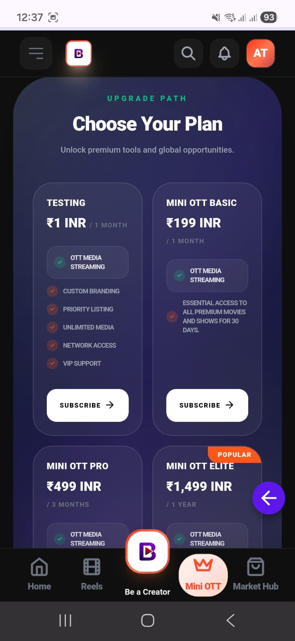

11) 6.1 ) dark mode and light mode testing on samsung s21fe

https://drive.google.com/file/d/1kl70mwKexqYb4ppHakcQw5ZO-C-ATPIr/view?usp=sharing

12) 6.2 ) save audio theme tested on samsung s21fe

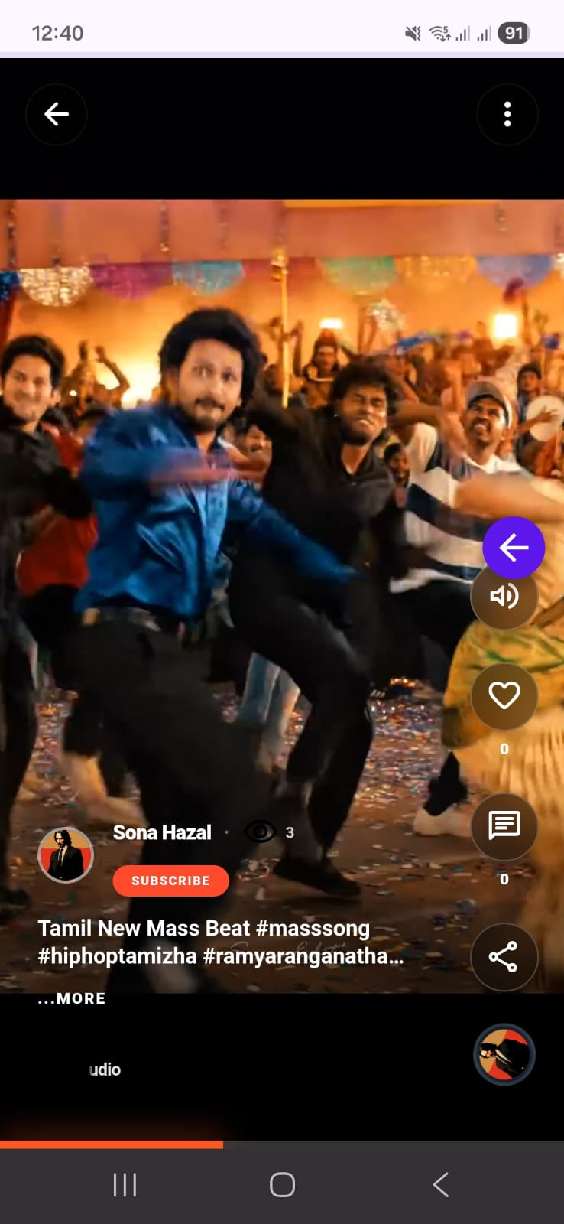
13)

13) 6.3) icon visibility in dark mode tested on samsung s21fe

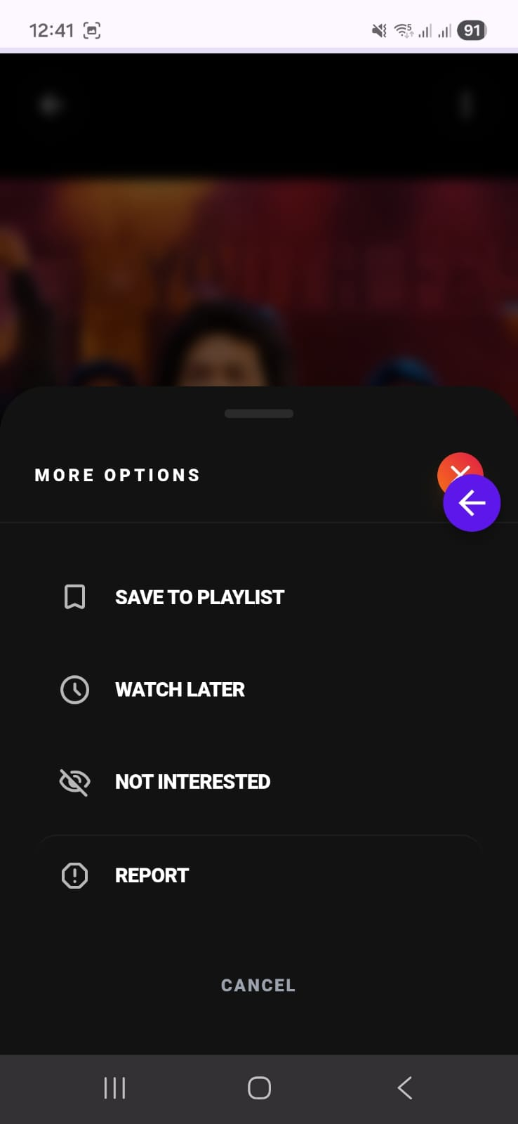

14) 8.2)profile customization and analytics dark mode tested on samsung s21fe

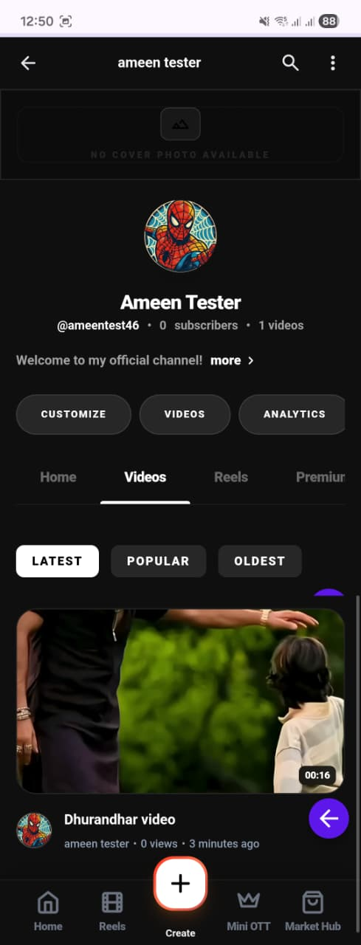

15) 8.3) profile video tested on samsung s21fe

16) 9.2) token genration toast message tested on samsung s21fe

17) 10.2 )mobile number validation tested on samsung s21fe

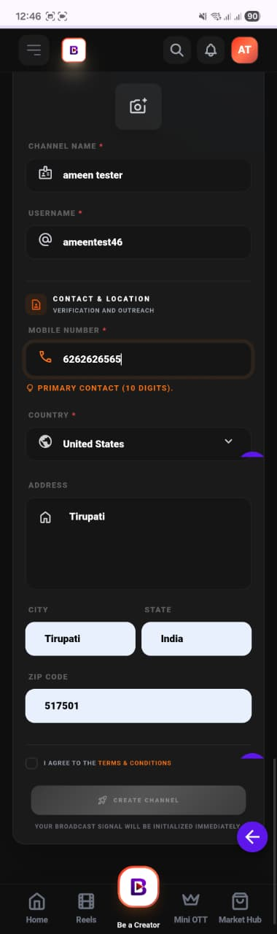

18) 9.3) support desk navigation redirection tested on samsung s21fe

https://drive.google.com/file/d/1ag2Tgy48mt8wrR7L8Kt6dtn_HPaD2Tfk/view?usp=sharing
19) 12.)Playlist video playback tested on samsung s21fe

https://drive.google.com/file/d/1yhLYlcXXuMxOW-4F-aqSqB_1nLq71jip/view?usp=sharing

20) 13.1 )reel page visibility tested on samsung s21fe

https://drive.google.com/file/d/1GI3XX7J6KLrnfn2B2ZE3gqwneJe-JqCI/view?usp=sharing

21) 13.2 )watch later tested on samsung s21fe

https://drive.google.com/file/d/1KwlpaQeE1Gt4n5h2ZwSEEzKfyWupYIN2/view?usp=sharing

22) 13.6 )Video button down control tested on samsung s21fe

https://drive.google.com/file/d/1Gr_ZuC5KTl8ayPq4KVPFxgPW0dXfxRJd/view?usp=sharing

--- MISSING ITEMS FROM ORIGINAL REPORT ---
11.1) Hide Video from Homepage
Status: PASS (Hide functionality and immediate feed update has been fixed via NotInterested/Hide logic)
11.2) Video After Reopening Application
Status: PASS (Feed correctly reflects hidden videos on reload)
13.3) Reel More Options
Status: PASS (Options tab opens correctly in both Light and Dark modes)
13.5) Uploaded Reel Playback
Status: PASS (Audio button visibility and stuck playback issues have been resolved)
15) Trending Section
Status: PASS (Colour presentation verified against UI design)

